ព្រះរាជាណាចក្រកម្ពុជា

ជាតិ​ សាសនា ព្រះមហាក្សត្រ

Institute of technology of Cambodia

Department of Information and communication Engineering



The lesson taking about Linked list function in c++

TP16: Linked list (part 2)

TP: Algorithm and Programming ll

Lecturer: BOU CHANNA

Student: VEN THON

ID: e20191250

Group: I3-GIC-C

Year: 2022-2023

Contents

Problem1: 3

Problem2: 5

Problem3: 7

Problem4: 9

Problem5: 11

# Problem1:

Create an element structure and a list structure that can store a list of integer numbers. Create 4 functions to

a. Create an empty list,

b. Add a number to begin of list,

c. Add a number to end of list,

d. Add a number to specific position in the list, and

e.Display list.

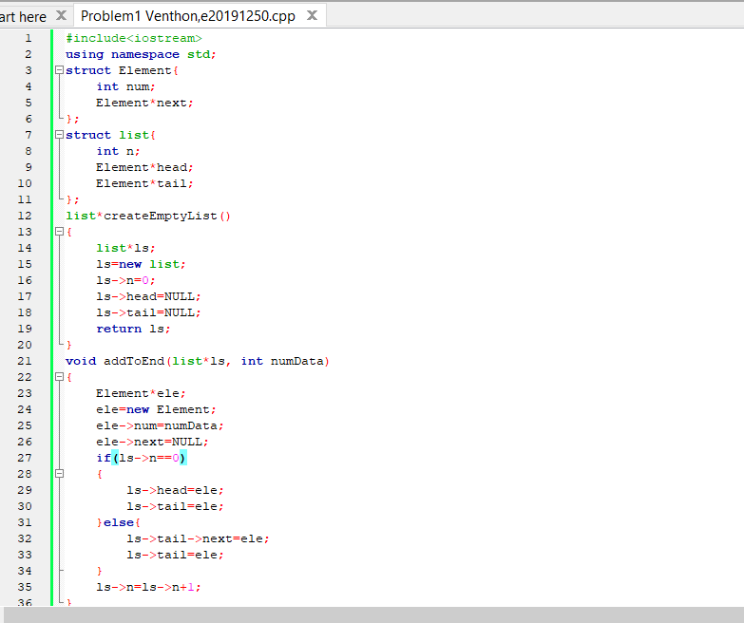

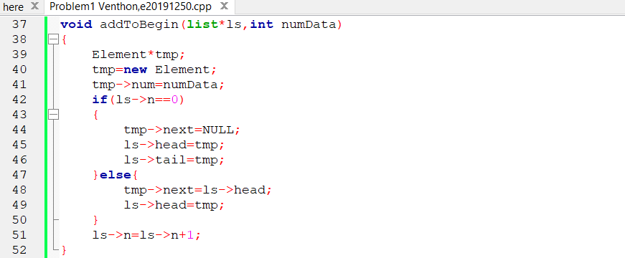

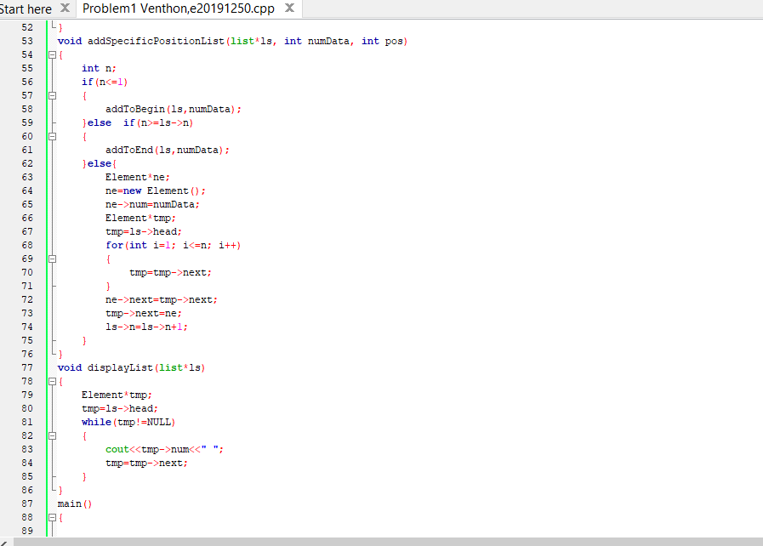

## Problem2:

Get a number n from a user. Include the user-defined header, yourName-SingleLinkList.h, created from problem #1. Build a singly linked list to store all numbers from 1 to n. Display all data in the list.

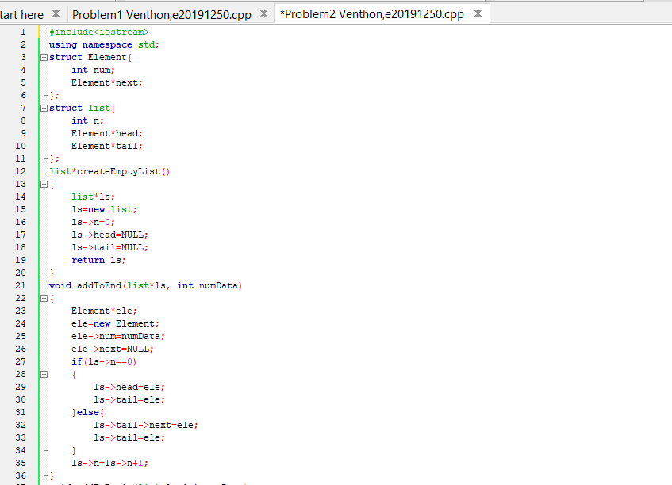

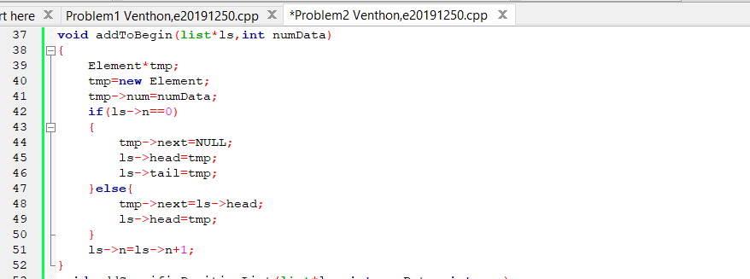

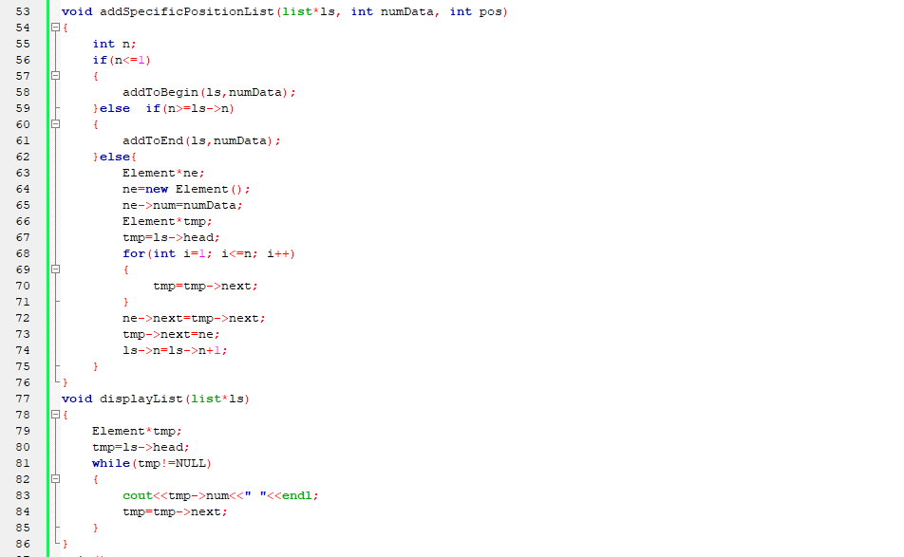

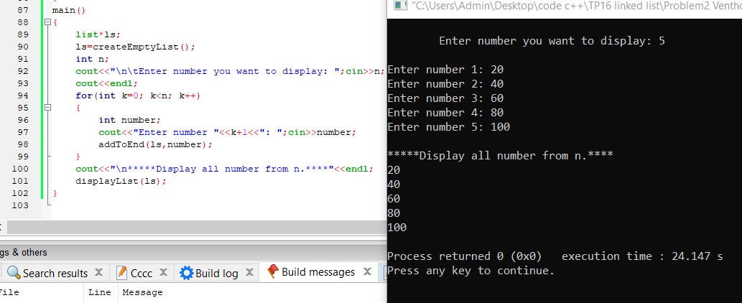

# Problem3:

Get a number n from a user. Generate n random numbers and store in the list.

a.Display the list.

b.Compute summation and average of all numbers in the list then display the result on screen.

c.Find the minimum and maximum numbers inthe list.

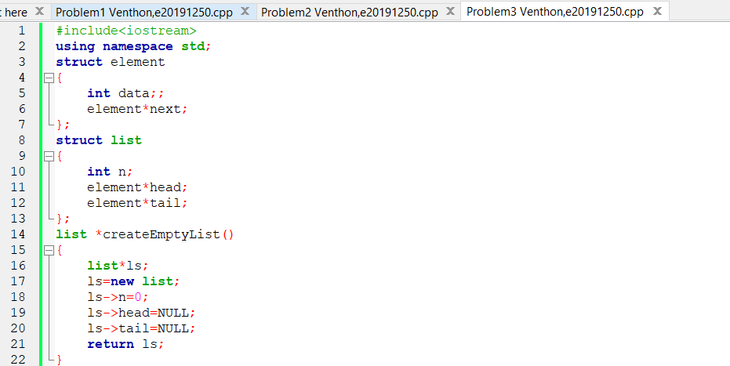

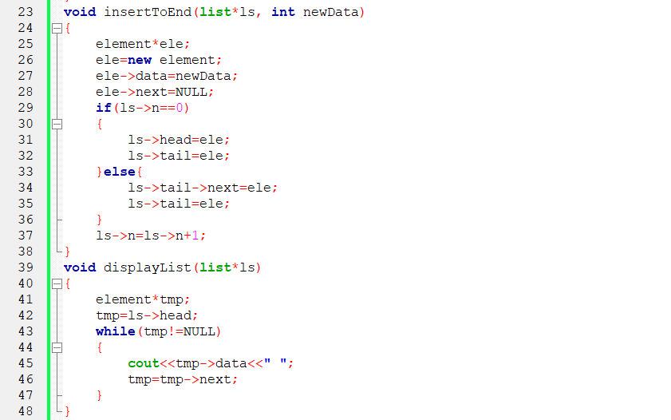

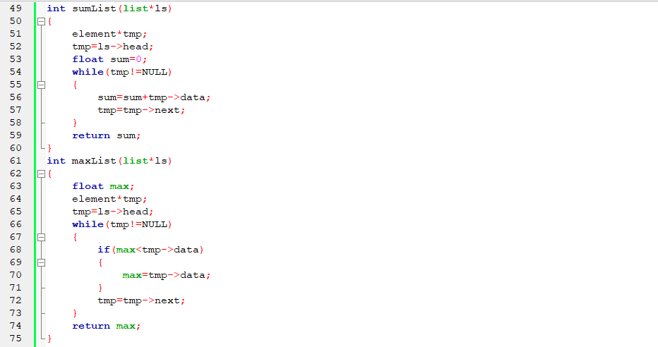

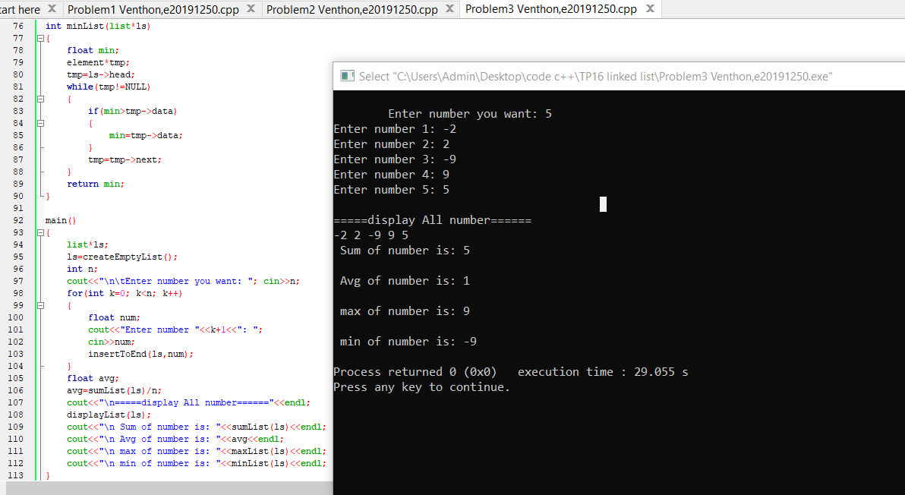

# Problem4:

Build a double linked list that is able to store a list of scores for I3 class. Data in the list includesstudent information such asname, ID, sex, score.Create some functions below:

a.Create structure element and list

b.Create a function to createan empty list

c.Insert data to begin of the list

d.Insert data to end of the list

e.Display data from beginof the list

f.Display data from end of the list

g.What is the average of the score?

h.Display list of students who got score more than the average.

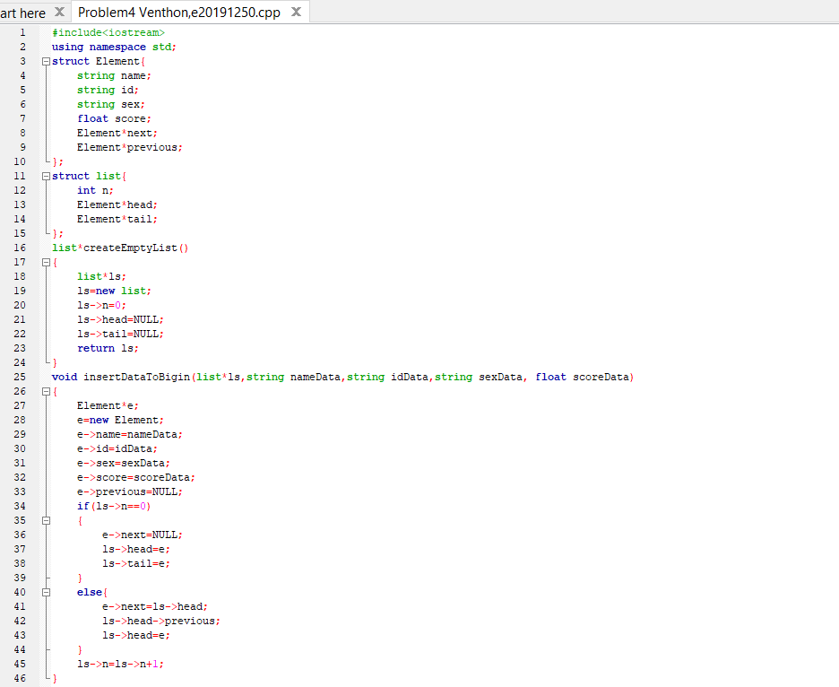

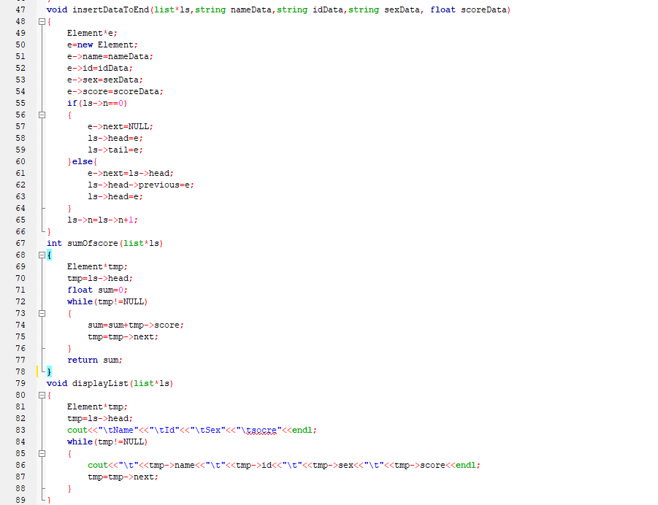

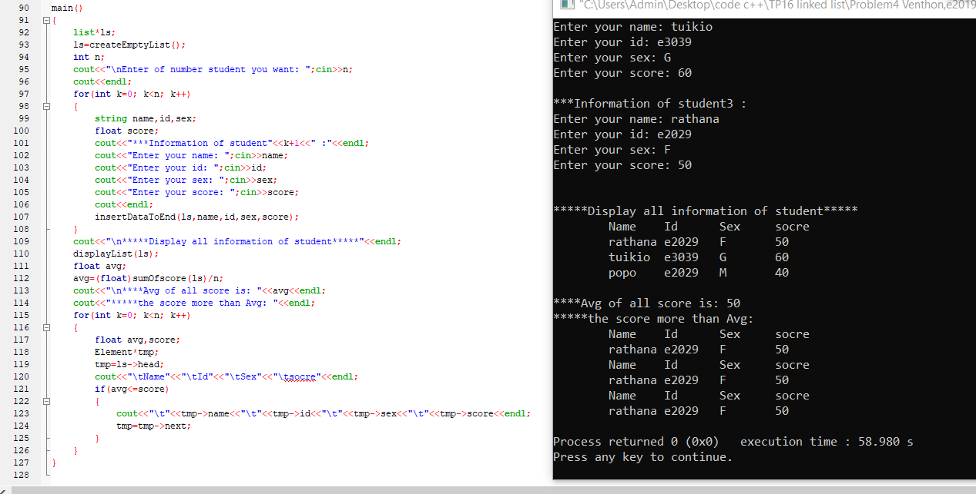

# Problem5:

reate a double linked that can store Englishalphabets (A-Z anda-z).a.Display the alphabets from Ato Z

